**MCOU "Sangishinsky basic comprehensive school"**

[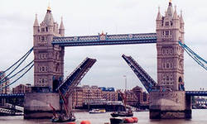](http://images.yandex.ru/yandsearch?source=wiz&img_url=http://vev.ru/uploads/images/00/00/76/2012/05/04/Tower-Bridge-London.jpg&p=2&text=%D0%B4%D0%BE%D1%81%D1%82%D0%BE%D0%BF%D1%80%D0%B8%D0%BC%D0%B5%D1%87%D0%B0%D1%82%D0%B5%D0%BB%D1%8C%D0%BD%D0%BE%D1%81%D1%82%D0%B8%20%D0%BB%D0%BE%D0%BD%D0%B4%D0%BE%D0%BD%D0%B0&noreask=1&pos=63&lr=39&rpt=simage)

Prepared and held

Yulusheva A.M.

**Цели:**

актуализация изученного материала, развитие логичес­кого мышления и произвольного внимания, поддержание интереса учащихся к изучению английского языка, развитие грамматических и лексических навыков.

**Оборудование:**

компьютер, презентация, проектор, набор карточек с количеством очков, карты.

**Ход мероприятия:** Hello, my dear boys and girls! I am glad to see you today. Do you like to play games? Today we will play a game «brain-ring». In this game will be attended two commands are All you need to do is to listen closely to my questions and answer correctly on them. It´s time to start our game!

Участники - 2 команды - рассаживаются за двумя столами. На столах флажки, которые капитаны будут поднимать в качестве знака, что ответ готов.

**1 I shall ask you some questions about London:** Each team will have 5 questions from different branches of knowledge: history, geography, policy, literature, arts education. You will get one point for each right answer. If you can't answer the question, your opponents will try to do it.

1. Who gave London its first name?

1. The Egyptians

2. The Greeks

3. **The Romans**

2. Which river runs through London?

**1. The Thames**

2. The Seven

3. The Seine

3. Who founded the Tower of London?

1.Charles I

**2 .William I**

3. Henry VIII

4. What is the name of the London's residence of Queen Elizabeth II?

1. Windsor Palace
2. Kensington Palace
3. **Buckingham Palace**
4. St. James's Palace

5. What title does Prince Charles, the oldest son of the British Queen, have?

1. Prince of Northern Ireland
2. Prince of England
3. Prince of Scotland
4. **Prince of Wales**

6. Whose monument stands in the centre of Trafalgar Square?

1. **Admiral Nelson**
2. General Washington
3. Former prime minister Winston Churchill
4. Abraham Lincoln

7. Name the English city:

1. Odessa
2. Madrid
3. Nice
4. **Manchester**

8. What is the town where William Shakespeare was born?

1. Sheffield
2. Coventry
3. London
4. **Stratford-on Avon**

9. William Shakespeare was...

1. artist
2. doctor
3. **writer**
4. sportsman

10. What theatre was organized by William Shakespeare?

1. **Globe Theatre**
2. Old Vic Theatre
3. Royal Theatre
4. Dall's theatre

**2. Now you will see some slides! It’s your task will be to guess what these slides show:**

1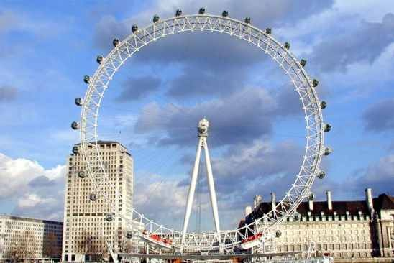 2 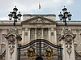 3 [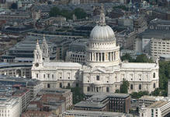](http://images.yandex.ru/yandsearch?source=wiz&text=%D0%B4%D0%BE%D1%81%D1%82%D0%BE%D0%BF%D1%80%D0%B8%D0%BC%D0%B5%D1%87%D0%B0%D1%82%D0%B5%D0%BB%D1%8C%D0%BD%D0%BE%D1%81%D1%82%D0%B8%20%D0%BB%D0%BE%D0%BD%D0%B4%D0%BE%D0%BD%D0%B0&noreask=1&img_url=http://upload.wikimedia.org/wikipedia/commons/1/1a/St_Pauls_aerial.jpg&pos=29&rpt=simage&lr=39)

4 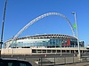 5 [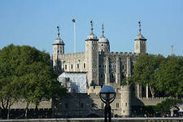](http://images.yandex.ru/yandsearch?source=wiz&img_url=http://b1.vestifinance.ru/c/34789.640.jpg&p=1&text=%D0%B4%D0%BE%D1%81%D1%82%D0%BE%D0%BF%D1%80%D0%B8%D0%BC%D0%B5%D1%87%D0%B0%D1%82%D0%B5%D0%BB%D1%8C%D0%BD%D0%BE%D1%81%D1%82%D0%B8%20%D0%BB%D0%BE%D0%BD%D0%B4%D0%BE%D0%BD%D0%B0&noreask=1&pos=47&lr=39&rpt=simage) 6 [](http://images.yandex.ru/yandsearch?source=wiz&img_url=http://vev.ru/uploads/images/00/00/76/2012/05/04/Tower-Bridge-London.jpg&p=2&text=%D0%B4%D0%BE%D1%81%D1%82%D0%BE%D0%BF%D1%80%D0%B8%D0%BC%D0%B5%D1%87%D0%B0%D1%82%D0%B5%D0%BB%D1%8C%D0%BD%D0%BE%D1%81%D1%82%D0%B8%20%D0%BB%D0%BE%D0%BD%D0%B4%D0%BE%D0%BD%D0%B0&noreask=1&pos=63&lr=39&rpt=simage)

|  |  |
| --- | --- |
|  | **Answers:** |

1-London Eye 2-Buckingham Palace 3- St Paul’s Cathedral, 4-Wembley 5-the Tower of London Stadium 6- London Bridge.

**3. I give you the maps and you must write down the parts of United Kingdom**:

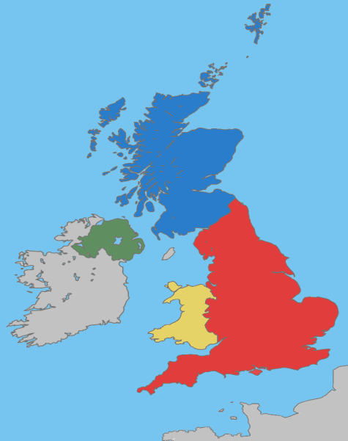

**4. You must connect the names (Соедините полное имя с сокращенным):**

1. Elizabeth a) Mik

2. Thomas b) Bobby

3. William c) Pat

4. Susan d) Tony

5. Michael e) Sue

6. Robert f) Pam

7. Patric or Patricia g) Bill

8. Anthony h) Tom

9. Pamela i) Liz

**Answers:** 1i, 2h, 3g , 4e, 5a, 6b, 7c, 8d, 9f

5**. Famous people of England. Do you know them?**

1.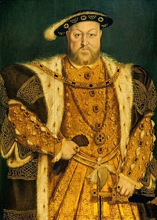 2. 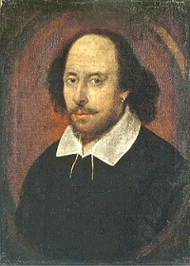 3. 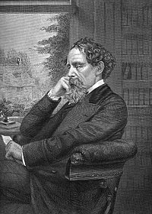 4

4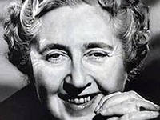. 5. [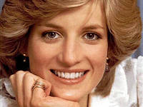](http://images.yandex.ru/yandsearch?text=%D0%BF%D1%80%D0%B8%D0%BD%D1%86%D0%B5%D1%81%D1%81%D0%B0%20%D0%B4%D0%B8%D0%B0%D0%BD%D0%B0&img_url=http://gorod.tomsk.ru/i/u/4882/Diana_Spenser021.jpg&pos=0&rpt=simage) 6.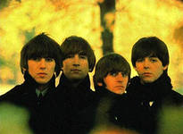

1. Henry VIII Tudor 2. William Shakespeare. 3. Charles Dickens 4. Agatha Christie 5. Diana Spencer 6. "The Beatles".

6. **In this competition you`ll have to make up a story. Arrange the sentences in logical order to make up a story. Think of a title for it and write it down**

**Текст 1**

Cambridge is one of the old university towns of England.

The university consists of many colleges.

These colleges are of grey stone.

Parts of Cambridge have not changed since they were built hundreds of years ago.

It is one of the most interesting towns in the Great Britain.

There are very old bookshops in Cambridge.

They are always full of people.

They look for and interesting book on the bookshops.

**Текст 2**

Oxford is one of the most beautiful cities in England.

Its university is the oldest in the country.

Every year hundreds of young people come to Oxford from school.

They spend three of four years at the university.

Tourists like to visit Oxford while they are in England.

It has many interesting buildings.

The most important street of Oxford is High Street.

Usually it is full of people, cars and bicycles.

7. **In the next competition you`ll have to complete the crossword: Countries and Nationalities. Take sheets of paper and get ready to begin. The quickest and the most correct will be the best.**

**Crossword:** Countries and Nationalities

**DOWN**

1. He is British. He comes from…

2. She is Italian. She lives in…

3. He comes from Sweden. He is…

4. They are Dutch. They come from…

5. He was born in China. He is…

6. We come from Greece. We are…

7. He is German. He was born in…

8. She is Danish. She comes from…

9. Mr. and Mrs. Carter come from the USA. They are…

**ACROSS**

1. She is Swiss. She comes from…

2. He is Polish. He was born in…

3. My girlfriend is… She was born in France.

4. He comes from India. He is…

5. They come from Norway. They are…

6. He was born in Russia. He is…

7. She is Spanish. She comes from…

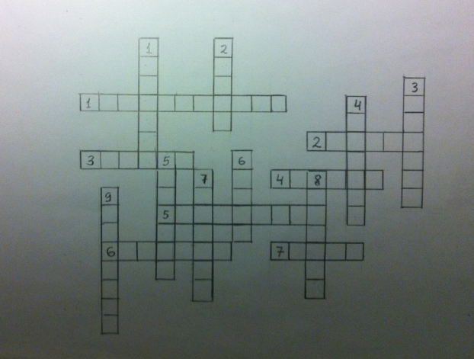

8. **I wonder what you know about English - speaking countries. Try to remember all information about these countries. Will you answer the following questions?**

1) Where is Great Britain situated? (On the British Isles).  
2) What are the four parts of Great Britain? (England, Wales, Scotland, Northern Ireland).  
3) What is the full name of Britain? (The United Kingdom of Great Britain and Northern Ireland).  
4) What is the only country in the world which occupies a whole continent? (Australia).  
5) What is the capital of Australia? (Canberra).  
6) What country is sometimes called “The World`s Biggest Farm”? (New Zealand).  
7) What languages are spoken in New Zealand? (English and Maori).  
8) Which country stretches from the Atlantic Ocean in the east to the Pacific Ocean in the west? (The United States of America).  
9) What motto do the USA have? (“In God We Trust”).  
10) What is the second largest country in the world? (Canada).  
11) What is the official emblem of Canada? (the maple leaf).  
12) What official languages are spoken in Canada? (English, French).

9. **Now, will you solve the chainword “Town”. Find nineteen words on the topic “Town”. Take sheets of paper, please. Write down the words one after another under the chainword.**

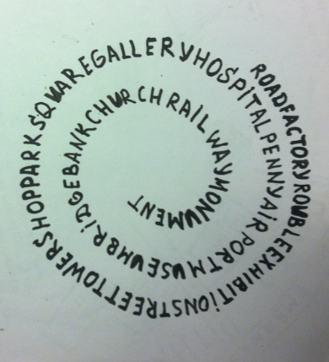

10. **Do you know famous people. Listen and say who they were.**

1) He discovered Australia. (Captain James Cook).  
2) An English writer, whose most famous novel is “Robinson Crusoe”. (Daniel Defoe).  
3) He was the prime minister of Great Britain during World War II. (Sir Winston Churchill).  
4) He was the first person to be elected the President of the United States. (George Washington).  
5) He was the youngest President the USA has ever had, but he was assassinated in 1963. (John Kennedy).  
6) An English writer of popular books and plays who wrote 75 detective stories. (Agatha Christie).  
7) He was the architect of the famous St. Paul`s Cathedral. (Sir Christopher Wren).  
8) He was the National Hero of Britain, the defender of the poor people. (Robin Hood).

11**. A good captain is the flag of the team. Competition of the captains. Will you give the name of each tourist sight or attraction?**

1) Here you can see was models of famous people. (Madame Tussauds`s).  
2) This is the Queen`s residence in London. (Buckingham Palace).  
3) This building was rebuilt by Christopher Wren after the Great Fire of London in 1666. It has a famous “Whispering Gallery”. (St. Paul`s Cathedral).  
4) MPs debate and argue here, and there is a clock tower with a famous bell in it. (the Houses of Parliament).  
5) It is the oldest public building in Washington, D.C., and the beautiful home of every President of the USA. (The White House).  
6) It is the tallest building in Washington, D.C., and this is where laws are made. (The Capitol)

**Thank you very much, friends, for your participation in our competitions. You`ve worked very well today. Our programme is over and our judges are summing up.  
Подводятся итоги. Команда-победитель получает главный приз, остальные школьники, принимавшие участие в работе, – открытки, сувениры.**